4.3 ANSWERS TO EXERCISES

4.3 Exercise 1

1. a) acid b) both c) acid d) both e) base
f) base g) both h) both i) both j) both
k) both
2. a) H₂O b) HClO₄ c) HSO₄⁻ d) H₃O⁺
3. a) HCO₃⁻ (acid) and CO₃²⁻ (base), H₂O (base) and H₃O⁺ (acid)
b) HCO₃⁻ (base) and CO₂ + H₂O (acid), H₃O⁺ (acid) and H₂O (base)
c) H₂SO₄ (acid) and HSO₄⁻ (base), HNO₃ (base) and NO₂⁺ + H₂O (acid)
d) HSO₄⁻ (acid) and SO₄²⁻ (base), OH⁻ (base) and H₂O (acid)

4.3 Exercise 2

1. a) 3.00 b) 11.30 c) 2.60 d) 4.89 e) 1.65
f) 12.60
2. a) 1.0 x 10⁻³ moldm⁻³ b) 6.3 x 10⁻³ moldm⁻³ c) 1.0 x 10⁻³ moldm⁻³
3. 2.0 x 10⁻⁵ moldm⁻³
4. 76

4.3 Exercise 3

1. a) resists large pH change on addition of small amounts of acid or alkali
b) 4.60
c) CH₃CH₂COOH + OH⁻ → CH₃CH₂COO⁻ + H₂O
CH₃CH₂COO⁻ + H⁺ → CH₃CH₂COOH
d) 4.84 e) 4.30 f) 12.30
g) the buffer solution restricts the pH change to 0.24 units, but the water changes its pH by 5.30 units (from 7 to 12.3).
2. a) 2.85 b) 3.33 g c) 4.41 d) 4.77
3. 8.65
4. salt: acid ratio 1.58:1
5. a) 10.21 b) 10.01 c) 10.54 d) 13.00
e) buffering capacity has been exceeded, so cannot resist change in pH.

4.3 Exercise 4

1. a) i) 2.37 ii) 3.27 iii) 3.74 iv) 4.22 v) 11.85
b)
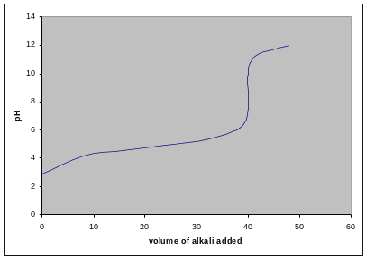
c) the salt produced is sodium methaoate, and the methanoate ion is basic:
HCOO⁻ + H₂O → HCOOH + OH⁻

2. a) 1.70 b) 12.30

3. a) b)
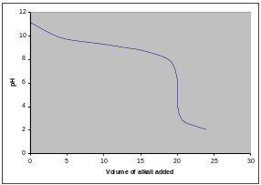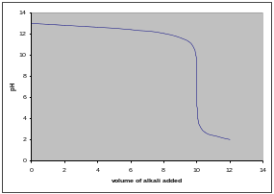
c) d)
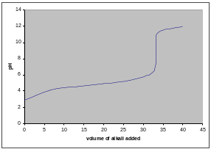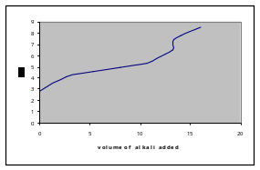

4. a) methyl red, as it will change colour completely within the pH range (4 –
7), over which the end point occurs
b) both, as they will both change colour completely within the pH range (4 – 10), over which the end point occurs
c) phenolphthalein, as it will change colour completely within the pH range (7 – 10), over which the end-point occurs
d) neither, as there is no sharp pH change at the end-point of this titration, so indicators will not change colour sharply

